Many Lakes Park Lands Fuel Reduction Notice

**Task:** Reduce fuel loading in Lake Meredith Park and Swimming Lake Park in Many Lakes subdivision

**Purpose:** Reduce hazardous fuels and reduce potential loss of life and property in the event of a wildfire

**End State:** Park lands with mixed-age-class trees. If fire gets into site, it would be low intensity

**Project Description:** Thin trees within Swimming Lake Park and Lake Meredith Park to obtain an approximate 10-foot spacing between crown of trees while pruning remaining trees according to technical specification guidelines. Treat all thinning slash and down woody fuels according to technical guidelines by piling and burning, chipping, or a combination of methods.

**Project Goal:** Manage the parks’ timber lands in a fashion that maintains an aesthetically-pleasing forest environment, practice forest management to enhance forest health by keeping healthy large trees spaced out so as not to compete with one another for water and soil nutrients, attain a mixed species and age class stand so as there are replacement trees in the future, and thin all young trees outside of drip line of large “leave trees.”

**Project Timeline:** Work on the County Parkland will run mid-January through February 2025. There could be some limited traffic delays around Lake Meredith for safety. The contractor will keep delays as short as possible.

**Further Information:** Any landowners who have questions or would like an evaluation for readiness in the event of wildfire may contact Flathead County Fire Warden, Lincoln Chute. Landowners may set up a time to meet for an evaluation and recommendations for the structures and timbered property.

**Lincoln Chute contact:** [lchute@flathead.mt.gov](mailto:lchute@flathead.mt.gov), 406-270-5634 cell

Lake Meredith Park Location

**Location:** Borders entirety of Lake Meredith and located on Tamarack Drive, South Many Lakes Drive, and Double Lake Drive on the East side of Many Lakes Vacation Village Subdivision.

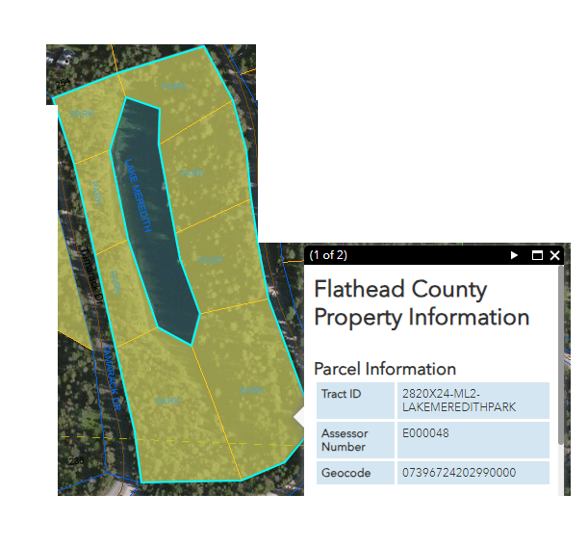

Swimming Lake Park Location

**Location:** Located at along the northwest side of Swimming Lake Ct including the Southern portion of the cul-de-sac at the terminus of Swimming Lake Ct toward the Northwest section of Many Lakes Vacation Village Subdivision. This park is South of Swimming Lake and Northwest of Gilbert Lake.

